**LOADING THE DATASET**

**TEAM ID : PNT2022TMID21549**

**PROJECT NAME : Global Sales Data Analytics**

* You must connect your data to IBM Cognos before you can create a view and perform any analysis. Cognos allows users to connect to a large range of data that is kept in many locations.

* The information may be kept on your computer in a spreadsheet or text file, or it may be kept on a server at your company in a big data, relational, or cube (multidimensional) database.

* In this instance, we'll do our analysis utilizing a spreadsheet or text file.

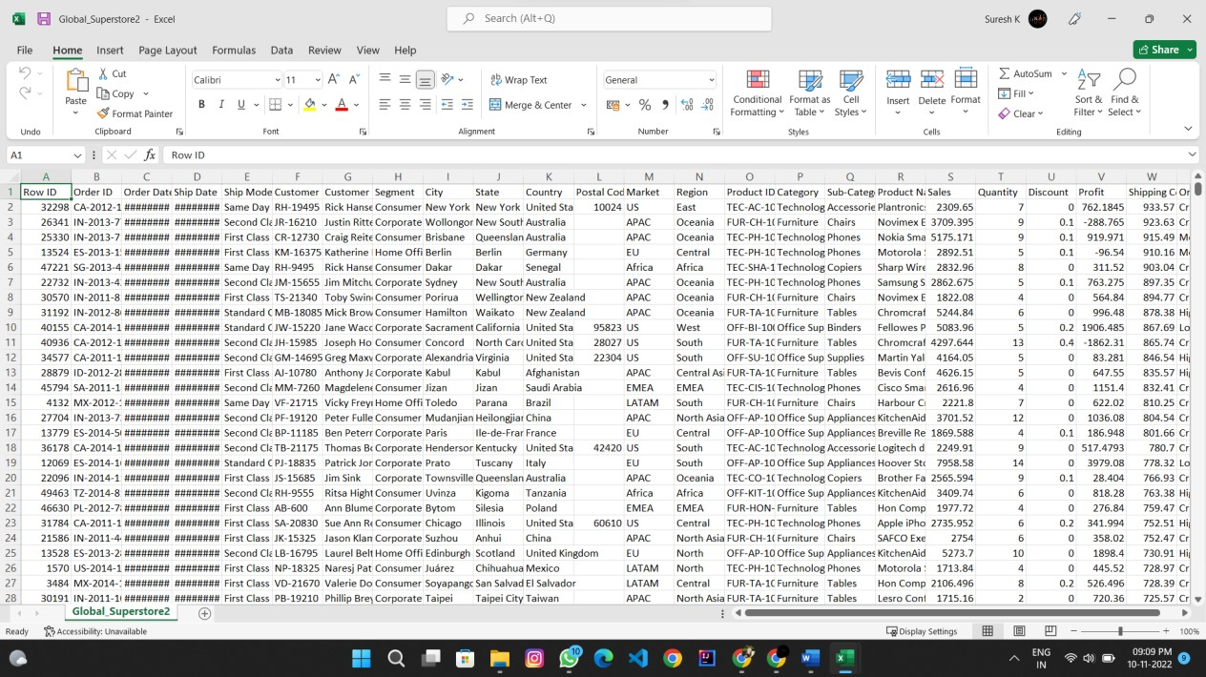

# UPLOAD DATA

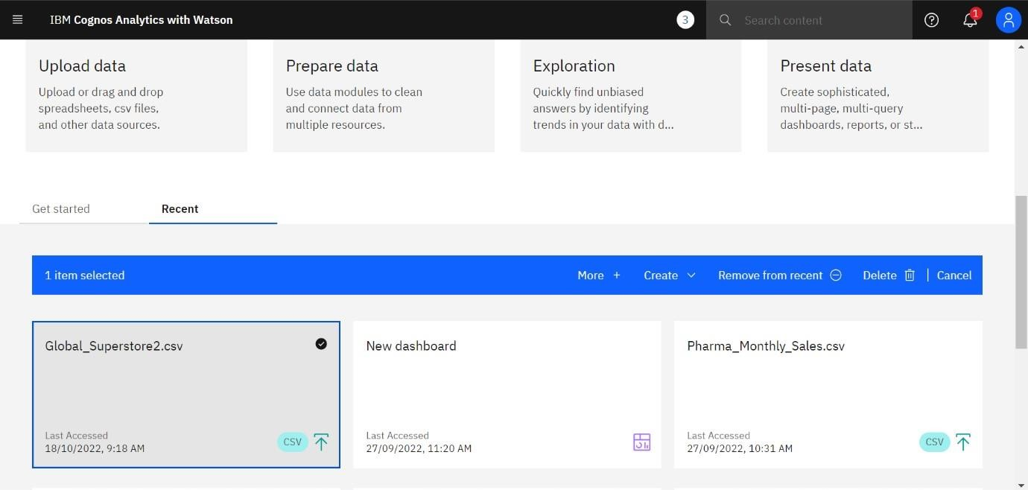

# PREPARE DATASET

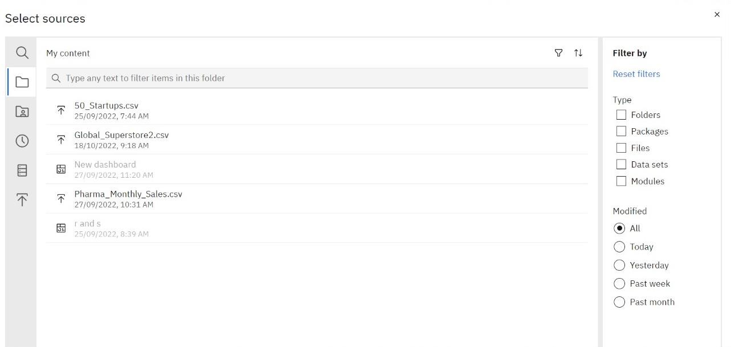

# SETECT THE DATASET

